10 Things I Wish You Knew
(A note from a special kid to special parents)


1. You are the perfect parents for me. I know that you did not sign up for a kid like me- I also know that you sometimes think you cannot face what it takes to raise me. I want you to know that this is not true. I believe that I chose you. Whatever you need to learn, you will learn. The strength you think you need will come from somewhere. The people you need to meet will show up when you need them.

2. This is the perfect life for me. My life is a very special one. I believe that I will impact the world in a unique and wonderful way. Remember this when your heart is breaking because you want a path for me that is so much easier than this one.

3. I need you to find your own spiritual path. The road we are on is not an easy one- to make it successfully, you will need all the spiritual strength you can muster for the tough days. You will need to help me when my spiritual strength is out the window. Often, you will see signs of my determination and be amazed by it. That is not enough. You will have to find your own answers. I am depending on you for it.


4. However you feel about me is OK. Sometimes you will feel tired and helpless and like you cannot care for me one more day. Sometimes you will be mad because there seems to be no escaping me. That is OK. There is no way you could take care of me without having those days. Sometimes you may watch people look at me and be a bit embarrassed that I am not doing better- that does not make you a bad parent… it just means you are human. Know that when you have lots of these days in a row, it is time for you to get somebody else to take care of me, just long enough for you to regenerate yourself. It is always important that you let people help you. I am depending on you to do whatever you need to do to take care of yourself.
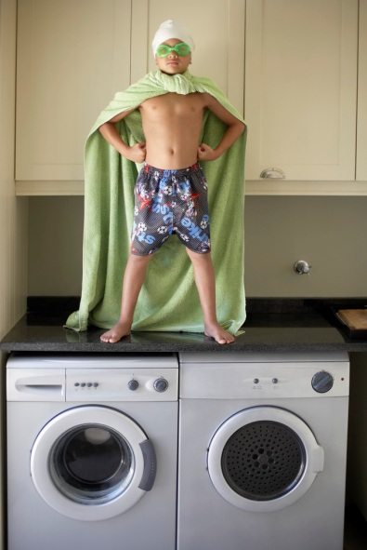
5. However I feel about my disability is OK. Some days you will be amazed at what a happy contented person I am and you will wonder how in the world I do it. Treasure those days. Some days I will be discouraged, some days I will be mad, some days I will even feel really sorry for myself. Don’t panic, I will come back around again. If you let me express these unattractive feelings, they have much less power. Even typical folks feel sorry for themselves sometimes.

6. Let me try things I want to try, even if you are sure I will fail. I know that you want to protect me- that is your job, I am your child. But I need you to understand that my survival is always going to depend on my determination. Part of my own process is to figure out what my limitations really are. Sometimes I may want to try to do things that seem impossible to you. Please encourage me anyway. It is the willingness to try that is important- success is a bonus. Know that if I fail, I will get over it. If you make me scared to try, I am really doomed.

7. Don’t worry about my whole life today. Sometimes you will drive yourself crazy worrying about how my life will turn out. You will lose hours of sleep trying to figure out how I will survive in the world after you are gone. This is not helpful to me. Just help me stay in today. The more you can focus on whatever we have to face today, the more you will be helping me develop the skills I will need when it is time for me to get along without you.


8. Sometimes people will be mean to me or scared of me. I expect you to stick up for me, but, I do not expect you to change the world. There are lots of really wonderful people in the world. You and I will meet many of them. There are also some real jerks who will be afraid of me or not treat me fairly. They will assume things about me that are not true. They may even assume things about you that are not true. You may want to blow their brains out. I may want to do the same. I expect you to speak up for me when you can. But I also need for you to be able to let it go. It will not help me if you are mad and defensive all the time. If you are, there are people who may not want to help me just because it is too hard for them to deal with you.

9. Finding good doctors and professionals is important but, you know me better than they do- I expect you to trust your own instincts about what is good for me. The doctors and therapists that work with me are going to be very important in the quality of my life. Some of them will be amazing and some of them will be pretty crazy. Often, it will be up to you to decide which is which. Listen to them, and know that what they say is important but, also remember that you know me best. If something they suggest does not feel right to you, listen to that small voice and speak up.


10. I really hope we can laugh. I believe that laughing was probably God’s best idea- It will be the one thing that can bring joy to our lives the quickest- If I get stuck in a mud puddle, it is probably funny. If you are lifting me and we both fall on the floor in a heap, that is probably funny too. A good joke is worth taking the time to laugh at- Help me not get so caught up in the serious problems we face every day to forget about laughing.

This amazing information was posted on November 20th, 2012 to Shut Up About Your Perfect Kid (http://www.shutupabout.com/blog/) by Sally Brown, who is 60 years old and lives with Cerebral Palsy. She shares her wisdom below.

Included with permission at Supporting Success for Children with Hearing Loss
https://successforkidswithhearingloss.com/10-things-i-wish-you-knew-a-note-from-a-special-kid-to-special-parents

